Xpath Axes examples:

1. Child example:

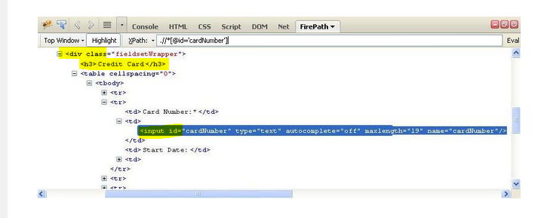

Xpath to select input id for card number will be

1. //div[h3/text()='Credit Card']/descendant::input[@id='cardNumber']

OR

1. //div[\*/text()='Credit Card']/descendant::input[@id='cardNumber']

Current Node

